**6.CHECK OUT SYSTEM**

**6.1** **Application for early end of mission:** This phase allows the user to prepare initiate Application for early end of mission.

1. After Login to the system select My Transaction menu which appear under .

2. select Application for early end of mission as shown with blue color.

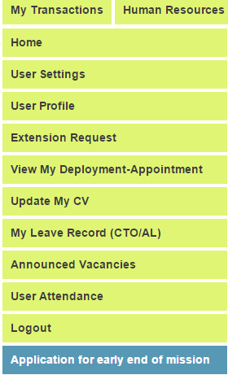

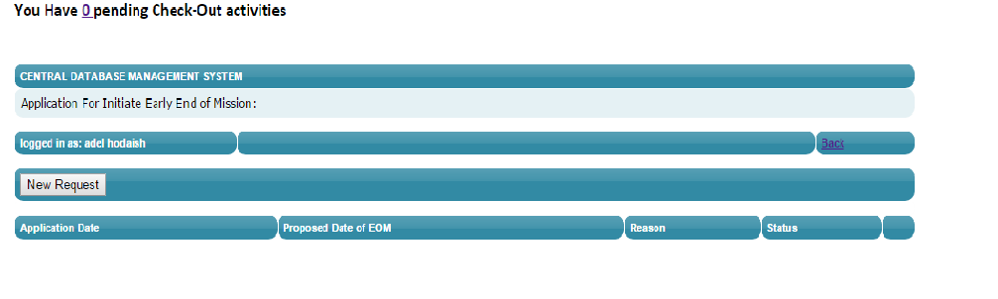

3. Click on the button NEW Request as shown in the above picture.

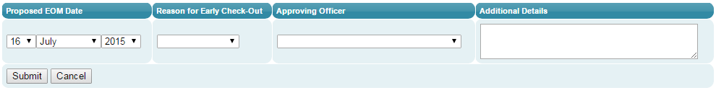

4. select the accurate date for proposed EOM and Reasone ,Approving officer and writte Additional Detials.

5.Click on Submit button as shown in the above picture to submit the application.

6. To cancel the Application just Click in the PLUS ICON  it will appear next page.

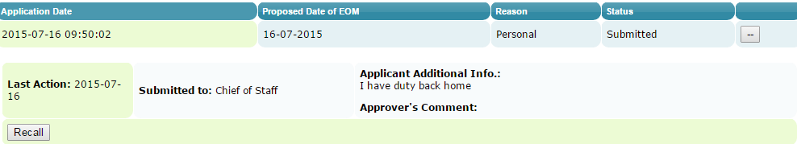

7.Click the Recall button .

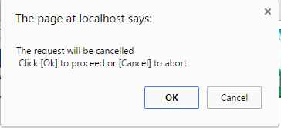

8. To confirm Click OK to cancel Click Cancel.



* **NOTE**: if the message above appear on the page without NEW Request button that mean(you have already application submitted or your check out date after 18 days and not allowed to apply in this period )

9. Approving the application it will appear in the next page.



10. Click on the number **1 .next page will appear.**



11**.** Click on the plus icon 

12. As approver officer select approve or reject and write comment the click submit.

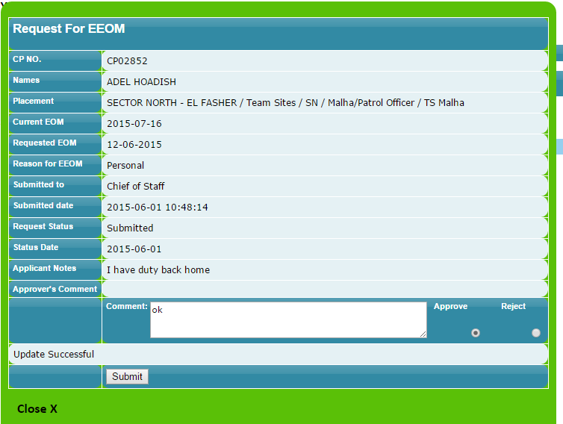

13. If the application approve the IPO will get Reminder as shown next page.



14. 11**.** Click on the plus icon 

15. If the application approved the bank details and luggage declaration page will appear as shown next.

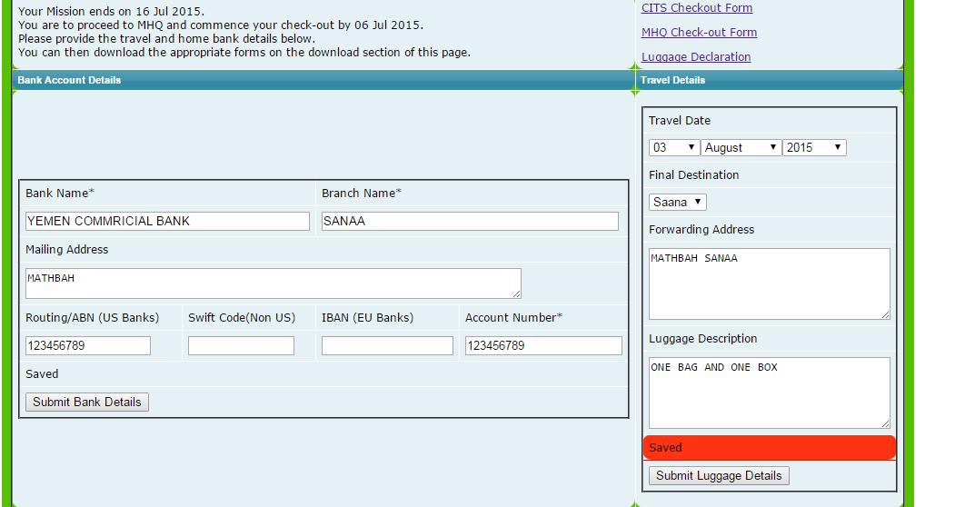

16. After adding bank details click submit button and after adding luggage declaration click submit luggage Details.

17. Printed out the CITS checkout Form, MHQ Checkout Form and Luggage Declaration Form.

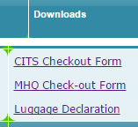

18. If the application Rejected the next page will appear as shown next.

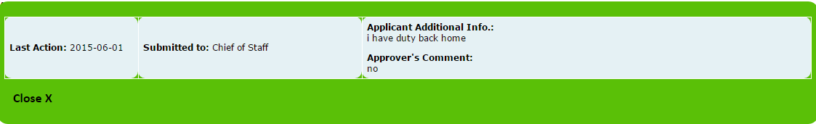

**6.2** **Add Destantion:** This phase allows the OIC to prepare check out destination.

1. Select from the menu Human Resources-check out->Destination as shown in the picture below.

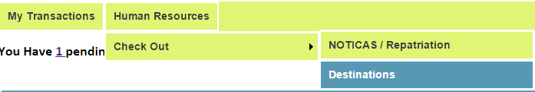

2.select the country name from drop down menu as shown in next picture.

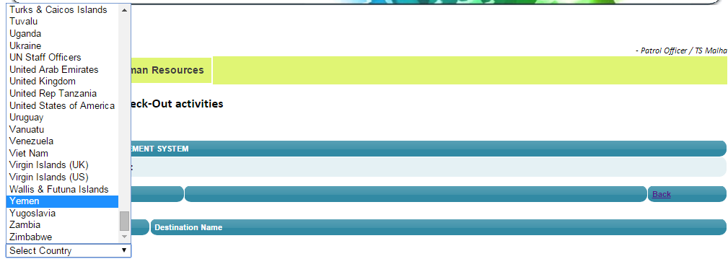

3. Add distention (town name) in the text box then click icon .



**6.3** **Add NOTICAS :** This phase allows the OIC to prepare initial notices related to any case or incident to approve from high authority.

1. Write your CP number or index number and Click Search.

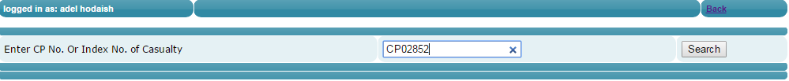

2. Click New Notices button.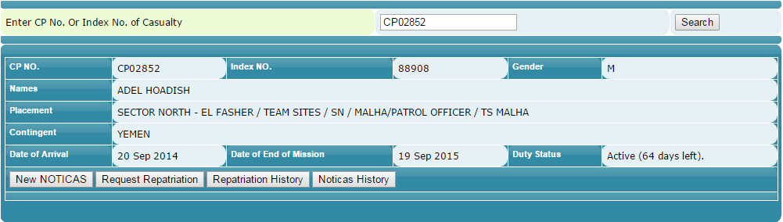

3. After adding all information in next picture click submit to submit data or cancel

To cancel.

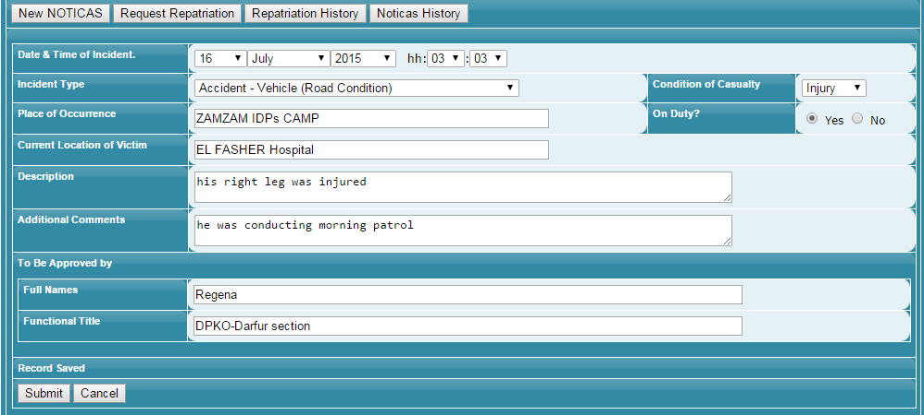

4. Click on The Notices History button.

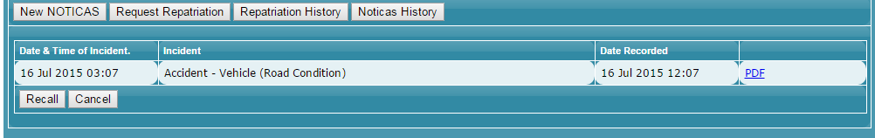

5. To printed out the notices Click  icon

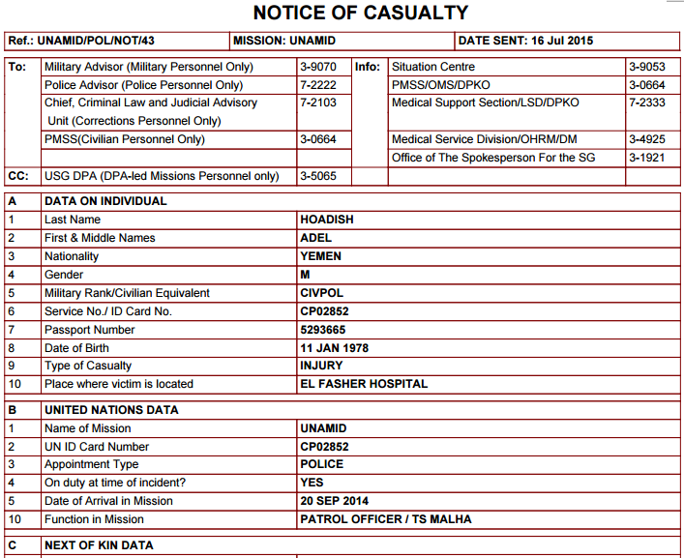

6. If there any a mastic or incorrect information in the notices Click Recall button  then create new notices.

**6.4** **Request For Repatriation :** This phase allows the OIC to prepare initial Repatriation Request after approving the Notices from high authority.

1. Click Repatriation Request button.



2. Add all information then Click Submit or Cancel to cancel to close the page.

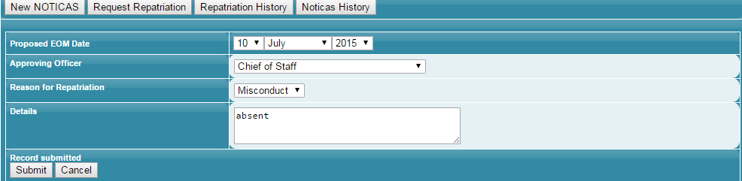

3. Click Repatriation History button.

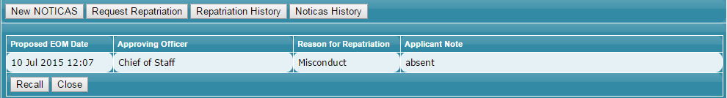

4. If there any a mastic or incorrect information in the request Click Recall button.

 Then create new request.

NOTE: if left only 18 or less than 18 days for the tour of duty the IPO the new notices and repatriation request and History buttons will not appear as shown in next picture.

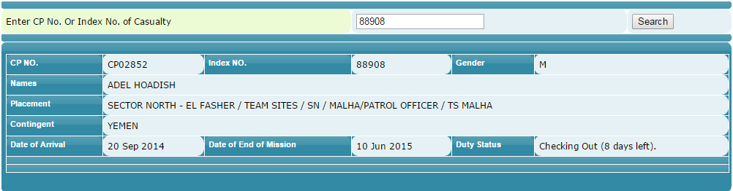

**6.5** **Check Out list :** This phase Generate the checkout list automatically every month in two formats PDF and EXCEL.

1.

2. Click the icon.

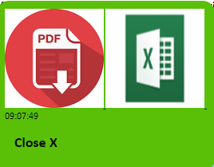

3. Click PDF to create the check-out list in PDF format.

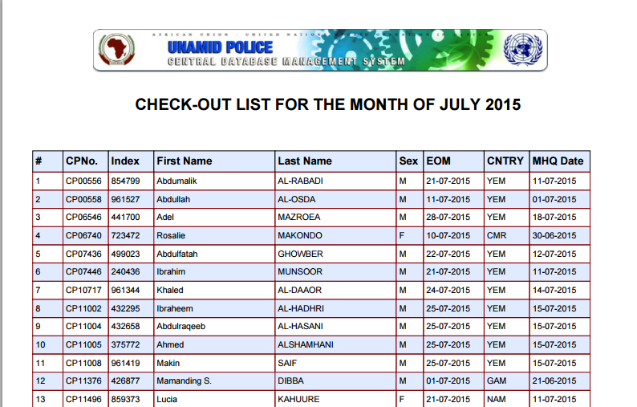

4. Click X to create the check list in Microsoft excels.

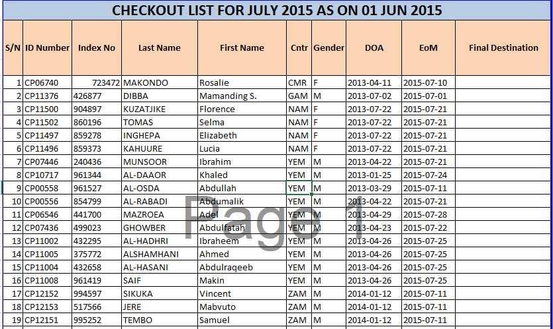

**6.6 Check Reminder :** This phase Generate the checkout Reminder automatically every month to allow the IPO in the checkout list to prepaid their bank details and luggage declaration.



1.Click the icon .

2. Bank details and luggage declaration page will appear as shown in page (5).

**6.6 Check Out Authrzition :** This phase allowed OIC personnel to assign any IPO to make check out process for Repatriated officer.

1. Go to Check Out/Authorization then Click.

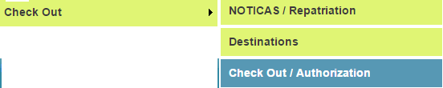

2. The next page will appear.

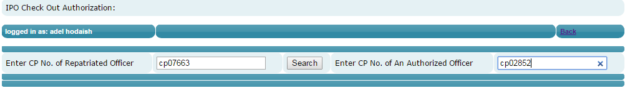

3.1 Enter the CP#No of the repatriated Officer in the left side text box.

3.2 Enter the CP#No of the Authorized Officer in the right side text boxes

3.3Click the button Search the page will appear as shown next.

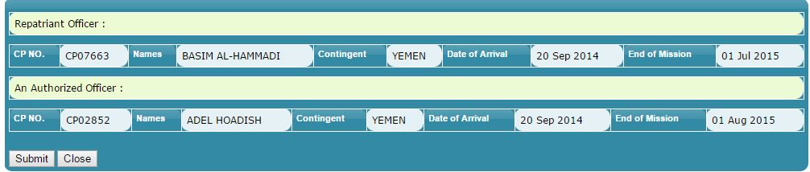

4.1 The information of the Repatriated officer it shows as on the first row in the above picture.

4.2 The information of the Authorized officer it shows as on the second row in the above picture.

5. Click submit button to submit the information and Click Close button to close the page.

